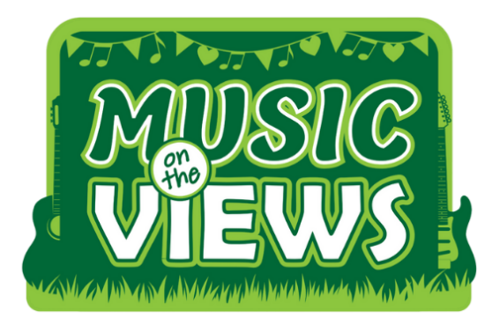

www.musicontheviews.co.uk – Box Office: 01252 811009
Essential Companion Scheme – Individual Membership
1. Details of person with disability
Full Name:
Address (including postcode):
Phone Number:
Email:
2. Application type:
Please tick one of the boxes below, as applicable.
If you are in receipt of any other benefit, we regret that you do not qualify for this scheme.
I am in receipt of the higher rate care or mobility component of the Disability Living Allowance / enhanced rate daily living or mobility component of the Personal Independence Payment / the higher rate of Attendance Allowance / hold Certificate of Visual Impairment / hold a Nimbus Access Card with the +1 symbol and would like to apply for a complimentary ticket for my Essential Companion.

I am in receipt of the middle rate care component of the Disability Living Allowance / the lower rate of the Attendance Allowance / standard rate daily living component of the Personal Independence Payment and would like to apply for a 50% ticket price reduction on an adult / top price ticket for my Essential Companion.

3. Supporting Documentation
Please include a photocopy of any of the following accessible documentation when sending this form (You may cross out any monetary amounts):
- Your letter from the Department of Work & Pensions confirming your DLA / PIP / Attendance Allowance status.
- Certificate of visual impairment.
- A Nimbus Access Card with the +1 symbol.

4. Details of personal representative / person who will be booking tickets
(if different from the person named above in section 1)
Full Name:
Address (including postcode):

Phone Number:
Email:
5. Please indicate your preferred contact
All correspondence will be addressed to this person.
*Please note if the person named in section 1 is under 16 we must have the name of a personal representative.
Person with disability (named in section 1)
Personal representative (named in (section 4)
6. Any other information…
Signed:
Print Name:
Date:

We will endeavour to process your application within 10 working days of receipt. If you are successful, we will issue your essential companion a free ticket alongside your paid ticket.
Please send your form and documents to customerservices@fleet-tc.gov.uk with the subject line:
MOTV Essential Companion.
Privacy Policy
This can be viewed on our website www.theharlington.co.uk, on our Contact page.
GDPR – General Data Protection Regulations
The information you provide is protected by GDPR and will only be used for the purpose set out in this document and to maintain records on eligibility. It will not be shared with any other agency. The scheme will be reviewed every 12 months.

